Setting up the Raspberry Pi Pico

Worksheet

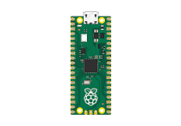

Setting up Raspberry Pi Pico

In this activity, you will set up Raspberry Pi Pico for use with an integrated development environment (IDE) and write some programs in Python to be executed on your Pico.

**You will need the following equipment:**

* Raspberry Pi Pico microcontroller
* Micro USB cable

To program Raspberry Pi Pico, you will use a piece of software called Thonny.

Thonny, it will look something like this it may vary slightly, depending on your computer settings and the version.











1. First you need to connect your Raspberry Pi Pico to your computer via the usb cable and the USB port on the PICO.
2. On Raspberry Pi Pico, press the BOOTSEL button and hold it while you connect the other end of the micro USB cable to your computer.

This puts your Raspberry Pi Pico into USB mass-storage device mode. That allows the setup of firmware. Firmware is software that provides basic instruction to the hardware.

1. In the bottom right-hand corner of the Thonny window, you will see the version of Python that you are currently using.

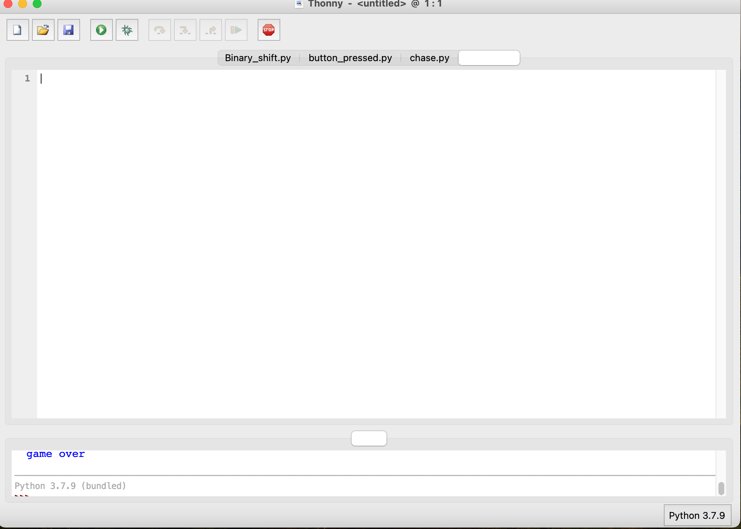

Click on the Python version and choose ‘MicroPython (Raspberry Pi Pico)’.

*NOTE: If you don’t see this option, check that you have plugged in your Raspberry Pi Pico.*

A dialog box will pop up to install the latest version of the MicroPython firmware.

Click the **Install** button to copy the firmware to your Pico.

Wait for the installation to complete and click **Close**. You don’t need to update the firmware every time you use Raspberry Pi Pico. Next time, you can just plug it into your computer without pressing the BOOTSEL button.

**Testing interaction with the Pico**

In this task, use the Thonny shell to run some simple Python code on Raspberry Pi Pico.

Look at the shell panel at the bottom of the Thonny editor.

You should see something like this image below:

Thonny is now ready to communicate directly with the Pico by typing Python code into the shell to see the output immediately.

**Type the following command directly into the shell and it will run on your Raspberry Pi Pico:**

**print(“Hello, Pico”)**

Tap the Enter key and you will see the output as below.

